**Azure Subscription Consumption**

**Project Plan**

**V2.0**

**Document Details**

|  |  |  |  |  |
| --- | --- | --- | --- | --- |
| **Created:** 8/30/18 | | | | |
| **Last Modified:** | | | | |
|  | | | | |
| **Version History:** | | | | |
| **Version No.** | **Date:** | **Updated By** | **Revised & Approved by** | **Description** |
| V1.0 | 6/11/18 | Alberto Escoto | Ernesto Brizuela  Manuel Molina |  |
|  |  |  |  |  |

# **Business Need**

Currently the joint effort between Microsoft and Tek-Experts is working under a model in which each support engineers has complete ownership of their azure subscription. This model worked in the initial stages of the organization since the overall control of resources could be achieve by team managers with the collaboration of Microsoft Service Delivery Managers. As the support teams keep growing and moving into a global scale operation the challenges to sustain this control become substantial.

Same as our customer working with cloud infrastructure demands to put in place policies and processes so that employees and business departments can take advantage of cloud services to drive resolution and confidence to our recommendations without compromising the security, compliance, governance or cost efficiency.

To understand the current model, we need to explain important areas to take in consideration:

* Understanding Azure Subscription
* Subscriptions Hierarchy
* Cost Management

**Understanding Azure Subscription**

To understand the bigger picture of managing Azure cloud infrastructure to our organization it is good to understand the proposed Azure Governance Wheel.

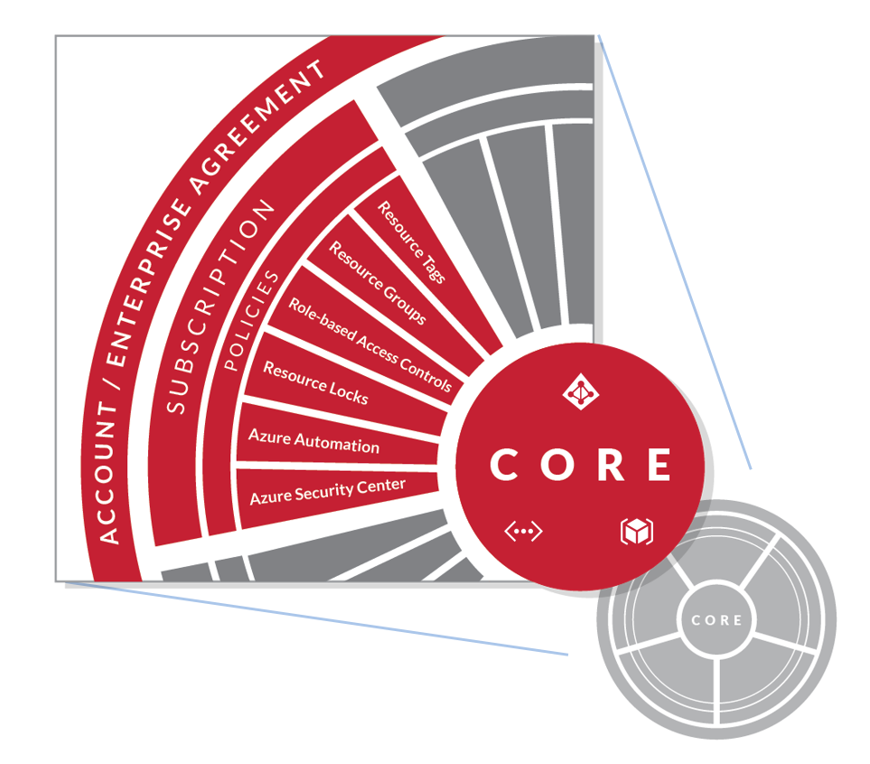

The Azure governance wheel explain some key components to be taken in consideration to manage not only the infrastructure been created but the cost that these services implies.

As it can be seen most Enterprise grade users would build their framework around an Azure EA license and take advantage of the delegations of subscriptions, resource groups, roles and automation tool to control the deployments. In the current structure of our operation, engineers have access over the entire account and subscription providing them unlimited access to the lower level options of control. This creates a roadblock for upper management to apply any sort of standard or policy to the usage of services since there is no ownership over their subscription.

The mitigation plan that Tek-Experts have used over the past has been focus on creation a series of Best practice to train the engineers on limited consumptions for key services.

Without a correct governance plan, then the organization can take advantage of feature such as Role Based Access Control. With these capabilities a Service Administrator or Account owner can apply restrictions over services which would prevent loss of data, controlled visibility over services or even mitigated possible security risks.

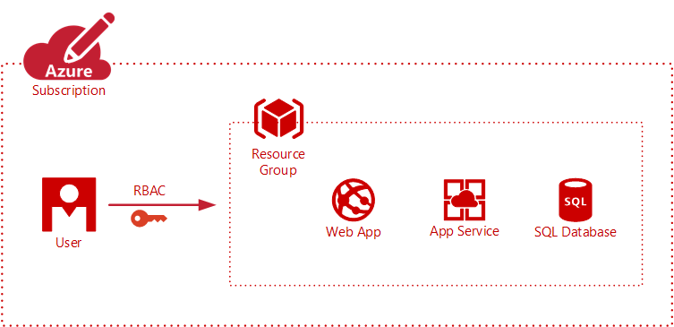

Given the importance of having governance over cloud services then it is imperative to comprehend under which hierarchy can the organization fit , based on needs.

**Subscriptions Hierarchy**

Currently all subscriptions are created from the AIRS engine. These steps are done by a Service Delivery Manager(SDM) since any new account must be added to a Microsoft Cost Center. Once the account is created then the Service Administrator and only owner is the SDM, to delegate this account then the engineer must be added as an Account owner.

Once the engineers have then necessary privileges then they have permissions to create, read, update and delete services. Based on this scenario then the SDM would be acting as the Enterprise Admin however the end users have almost the same permissions as an SDM with the expectation of billing usage.

One of the advantages of Azure subscription is that it can adapt to any type of organization in the market including support operation such as ours. To provide an example we need to take on basis of a hierarchy pattern

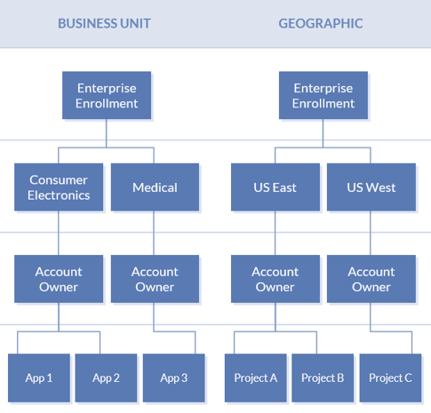

These two patterns have very similar approaches however puts in the table different perspective. Both patterns share ideas that could be taken in consideration due to the global scale of our support organization.

The approach we proposed is take advantage of the technical resources that the company has hired, to align the business needs of each team to the proper usage of service therefore impact the consumption.

Every team has at least have one Subject Matter Expert to train, mentor and support during technical escalations. SME’s are also technical point of contact for Team managers which provides them with context of the business priorities. All the previous attributes serve as a strong reason to change the current model to allow SME’s to handle the responsibility over subscriptions to delegate to the necessary parties.

**Cost Management**

For cost management the only reporting tool at hand is the AIRS usage report which any Service Admin can access. This provides a very details description of the services used however it is not user friendly. Parsing trough the data and understanding possible impact requires some knowledge not only on the technology but also on the pricing for the infrastructure. This same problem has been faced by multiple users in the market and had tackle it with many options such as the Azure billing API, Cloudlyn Solutions or event scripts.

Due to the nature of the support subscriptions we do not have permission to the API’s to create friendly dashboards. For this reason, we need to create a structure in which we can cover basic areas of interest:

1. Gain visibility over the Azure Cloud Environment
2. Empower the organization for cloud accountability
3. Drive cost management and optimization

SME’s will be vital in the optimization of all the topics mention due to the background on Azure services and the various perspective that we have from PaaS to IaaS, never the less this optimization journey can take some time to learn from mistakes and adapt.

Our initial efforts must be focus on the design of standards and policies which could be taken out of the Best practices guideline in which engineers have been trained.

# **Objective**

Create an Azure governance guideline which would include the standards and policies necessary to optimize cost efficiency and allow capabilities to provide visibility over the services consumed which should be done before September 30th ,2018.

# **Scope**

## Success criteria

* Create a Cost Management plan for Subject Matter experts and Managers. The document must contain:
  + Naming Conventions
  + Standards and Policies
  + Automation examples
* Define critical workloads or services for support scenarios
* Create a report for service usage and billing consumption
* Migrate current account to the new Azure governance Guidelines

.

# **Schedule**

|  |  |  |  |  |  |
| --- | --- | --- | --- | --- | --- |
| **Tasks** | **October** | | | | **November** |
| Week | 5th | 12th | 19th | 26th | 2nd |
| Create Cost Management Plan |  |  |  |  |  |
| Change Ownership for Subscriptions |  |  |  |  | |
| Delete Unnecessary resources |  |  |  |  | |
| Train SME and Managers on standards and policies |  |  |  |  |  |
| Automate VM shutdown |  |  |  |  |  |

# **Roles and Responsibilities**

|  |  |
| --- | --- |
| Tasks | Responsible |
| Create Cost Management Plan | Alberto Escoto |
| Define migration strategy for accounts | Ernesto Brizuela | Alberto Escoto |
| Define Service Hierarchy | Ernesto Brizuela | Manuel Molina |David Robles | Bosede Omolehinwa |
| Train Subs Admins standards and policies | Alberto Escoto | Andres Garcia |
| Delegate resource groups | SME’s |
| Automate VM shutdown | Subs Admins |
| Report Usage | Alberto Escoto |

# **Communications Plan**

To start the project rollout there will be a recurrence every Thursday until the week of June 16th.

|  |  |  |  |  |
| --- | --- | --- | --- | --- |
| Informed | Recurrence | Responsible | Approves | Informed |
| Consumption Report | Weekly (Weekly Business Review) | Alberto Escoto | Ernesto | Service Admin Community |
| Project updates | Weekly | Alberto Escoto | Ernesto | Service Admin Community |

# **Stakeholders**

|  |  |  |
| --- | --- | --- |
| Name | Position | Role within Project |
| Alberto Escoto | SME | Project Manager |
| Ernesto Brizuela | SDM | Project Sponsor |
| Manuel Molina | Global Ops Manager | Project Sponsor |
| David Robles | SDM | Project Sponsor |
| Bosede Omolehinwa | SDM | Project Sponsor |
|  |  |  |
| Andres Garcia | Support Eng. | Trainer |
| Service Admin Community | SME’s | TBD |